GAA Foundation , European Cultural Centre , Bel Air Fine Art

Present American Artist

Carole A. Feuerman’s Solo Exhibition
In Conjunction With the 57th Venice Biennale

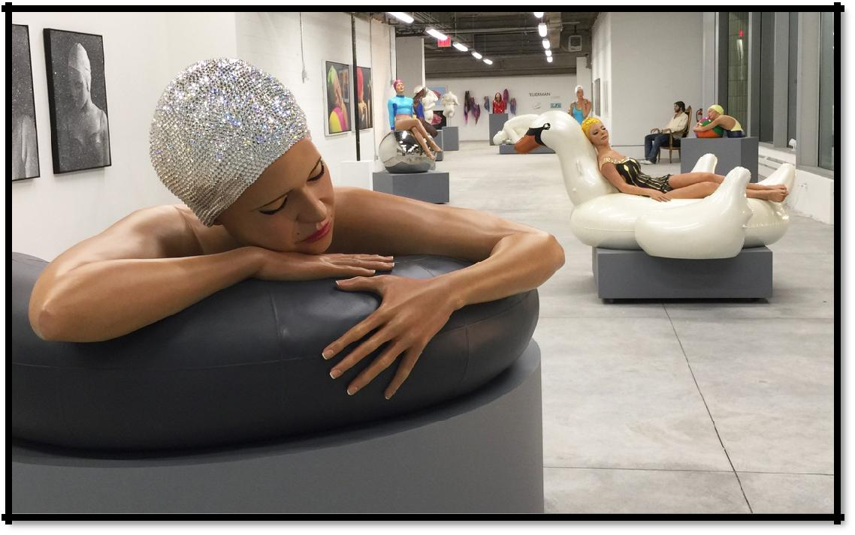

“Survival of Serena”, 84L x 32W x 38H, Patina & Swarovski Crystals, 2017

Presenting 8 New Public Art Sculptures in Giardino Della Marinaressa
on The Grand Canal, Riva dei Sette Martiri, 30122 Venezia, Italy

Preview Receptions: Thursday, May 11 & Friday, May 12
5:00 pm – 8:00 pm

Exhibitions Open to The Public: May 13 -­‐ December 5, 2017
Open Daily: 10:00 am-­‐ 6:00 pm

Bel Air Fine Art
Will Host a Reception and Dinner
Friday, May 12 at 8:00 pm -­‐ 10:00 pm
At Their Gallery, Calle dello Spezier, 2765, 30124 Venezia, Italy

Bisol Prosecco
Will Host a Solo Art Exhibition and Reception
Tuesday, May 9 at 6:00 pm
At Venissa Restaurant and Hotel on the Island of Burano
F. ta S. Caterina, 3 – Mazzorbo, 30142 Venezia – Italy

March 29, 2017 (New York, NY) American hyperrealist sculptor, Carole A. Feuerman will be presented by the Global Arts Foundation, Bel Air Fine Arts, and Bisol Prosecco at three exclusive exhibitions in Venice, Italy during the week of the Venice Biennale from May 9 - 12 2017.
Carole A. Feuerman is recognized as a pioneering figure in the world of hyperrealist sculpture. Together with Hanson and De Andrea, she was one of the three leaders that started the movement in the late seventies by making life sculptures that portrayed their models precisely. They are meticulously detailed to create the illusion of a new reality. Dubbed ‘the reigning doyenne of super-realism’ by art historian John T. Spike, Feuerman has solidified her place in art history.

Feuerman, through her sculptures, aims to create visual manifestations of inner balance and beauty. She is best known for her large-­‐scale sculptures of swimmers complete with water drops. “Swimming and water have fascinated me for as long as I can remember, and as a result, have become the essence of my inspiration for my pieces,” she said. Feuerman has spent the last four decades sculpting monumental, life-sized, and miniature works in bronze, resin, and marble. Her labor-intensive sculptures involve working on the piece both in wax and bronze, later applying multiple coats of primer and paint in the foundry, and finishes in the studio. Eight of these sculptures will be on view in the public park Giardino Della Marinaressa in the City of Venice, Italy from May – December 2017, sponsored by the Global Arts Affairs Foundation, European Cultural Centre and Bel Air Fine Art.

The Global Arts Affairs Foundation (GAAF) GAAF will host two openings for Carole A. Feuerman, who will be exhibiting eight new outdoor painted bronze sculptures in the Giardino Della Marinaress (Riva dei Sette Martiri, 30122 Venezia, Italy). The first opening will be on Thursday, May 11, 2017 and the next on Friday, May 12th from 5pm – 8pm in the park. The Exhibition will be open to the public beginning May 13 through December 5, 2017; open 10:00am -­‐ 6:00pm daily. GAAF is a non-profit organization that aims to heighten the awareness about contemporary art, architecture and culture, works to make art more accessible to a wider international audience.

Bel Air Fine Art (Calle dello Spezier, 2765, 30124 Venezia, Italy), with over sixteen galleries throughout Europe and the Middle East, will present a series of Carole A. Feuerman ’s lifesize sculptures and a collection of prints. Bel Air Fine Art will host their opening on Friday, May 12 in the Giardino Della Marinanessa from 5pm – 8pm with a reception at the Gallery at 8pm – 10pm.

Venissa (Fondamenta di Santa Caterina, 3, 30142 Mazzorbo, Venezia VE, Italy), owned by Bisol Prosecco, is a boutique hotel and world renowned restaurant on the Venetian lagoon island of Burano. Venissa will install lifesize sculptures throughout their property on May 10, 2017. Venissa will host a reception for the artist on Tuesday, May 9 at 6:00 pm with a dinner and reception to kick off the event. The exhibition will be open through September 2017.

Carole A. Feuerman ’s continues her focus on public outdoor sculptures and museum sized pieces. Feuerman maintains two studios in Chelsea, NY and at Mana Contemporary, in NJ. Her selected private collectors include the Emperor of Japan, President William & Secretary of State Hillary Clinton, Norman Brahman, the Caldic Collection, Mark Parker, Ariella Wertheimer, Robert Hurst, and Malcolm Forbes. On an ongoing basis, Feuerman's work can be seen in selected galleries and museums worldwide.

Bel Air Fine Art
Will host a Reception & Dinner
Friday, May 12 From 8:00pm - 10:00pm
Calle dello Spezier, 2765, 30124 Venezia, Italy
Invitation Only – RSVP HERE

Bisol Prosecco
Will host a Solo Art Exhibition & Reception for the Artist
Tuesday, May 9th at 6:00 PM
At Venissa Restaurant and Hotel on the Island of Burano
F. ta S. Caterina, 3 – Mazzorbo, 30142 Venezia – Italy
Invitation Only – RSVP HERE

www.carolefeureman.com
Facebook: https://www.facebook.com/caroleafeuerman/
Instagram: https://www.instagram.com/carolefeuerman/
Twitter: https://twitter.com/carolefeuerman

For More Information, Contact:
Jennifer Gross | Evolutionary Media Group
Jennifer@emgpr.com
O: 323-658‐ 8700
C: 323-646-8412

